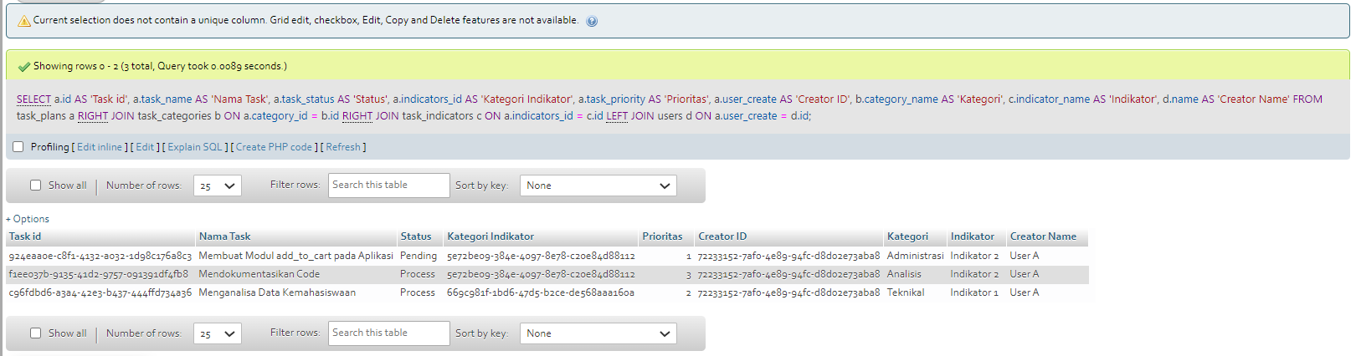

**SELECT**

**a.id AS 'Task id',**

**a.task_name AS 'Nama Task',**

**a.task_status AS 'Status',**

**a.indicators_id AS 'Kategori Indikator',**

**a.task_priority AS 'Prioritas',**

**a.user_create AS 'Creator ID',**

**b.category_name AS 'Kategori',**

**c.indicator_name AS 'Indikator',**

**d.name AS 'Creator Name'**

**FROM**

**task_plans a**

**RIGHT JOIN task_categories b ON**

**a.category_id = b.id**

**RIGHT JOIN task_indicators c ON**

**a.indicators_id = c.id**

**LEFT JOIN users d ON**

**a.user_create = d.id;**